The purpose of this document is to document the umbilical handling and support system used for the larva tracker. The following pictures show the umbilical handling approach. A cable guide by IGUS was used to control the camera and blue LED lighting cables (model number of the cable guide is provided in the BOM).

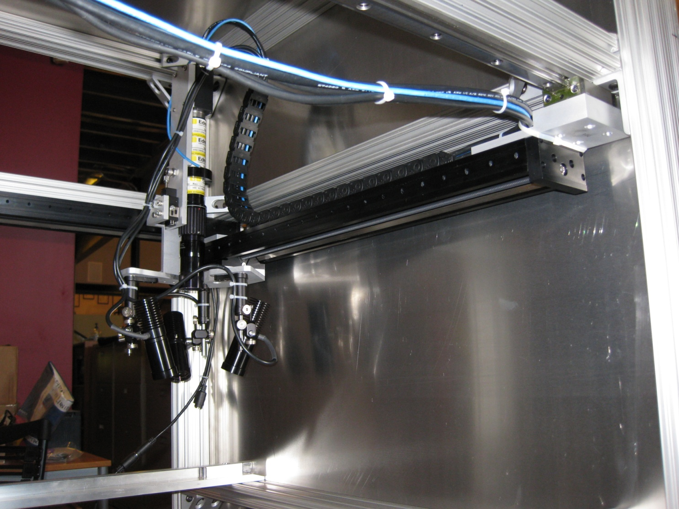

IGUS Cable guide was attached to and resting on the top side of the Zaber rail. The guide was anchored to the Zaber at this point.

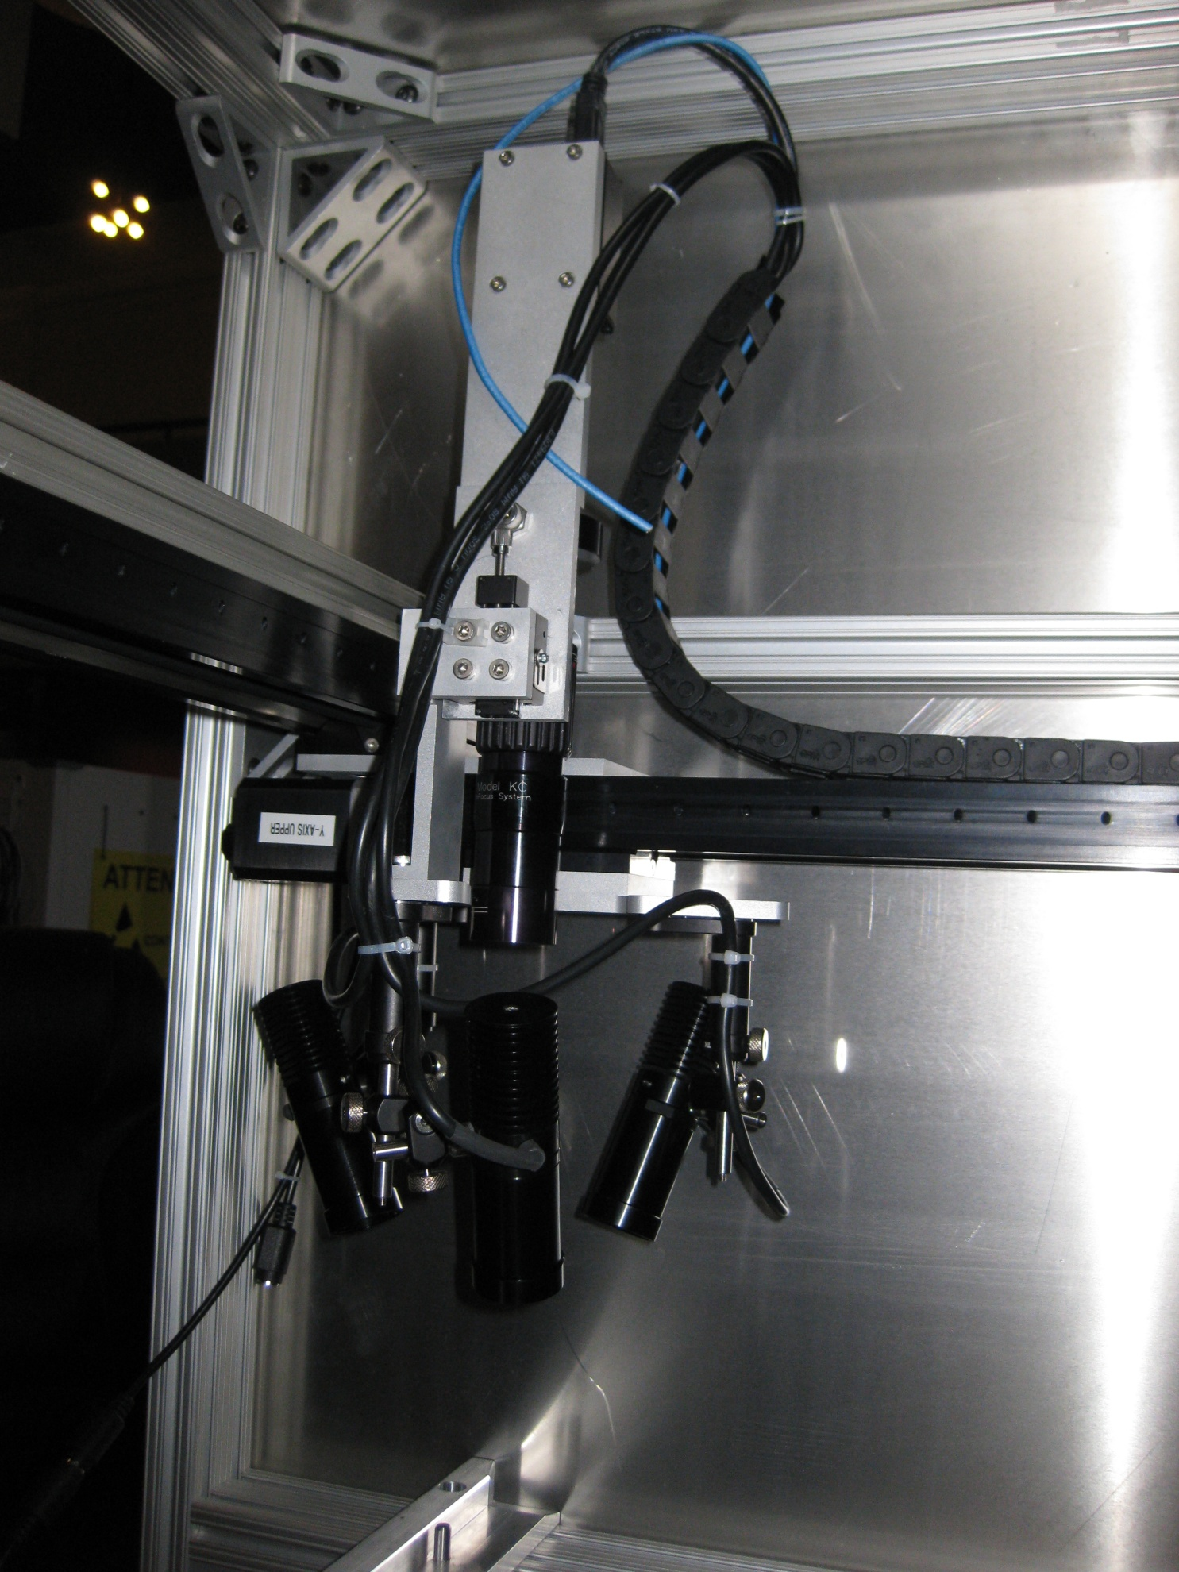

A two conductor, shielded wire was added to the assembly to trigger the camera (per HHMI request).

Cabling was tie-wrapped and anchored to mounting plates for strain relief.

IGUS Cable guide was about 20 inches long.

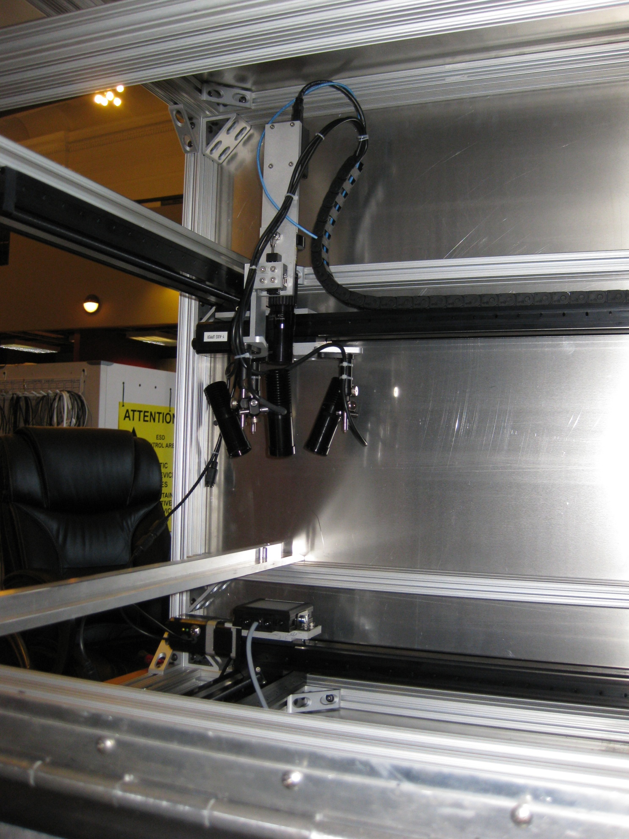

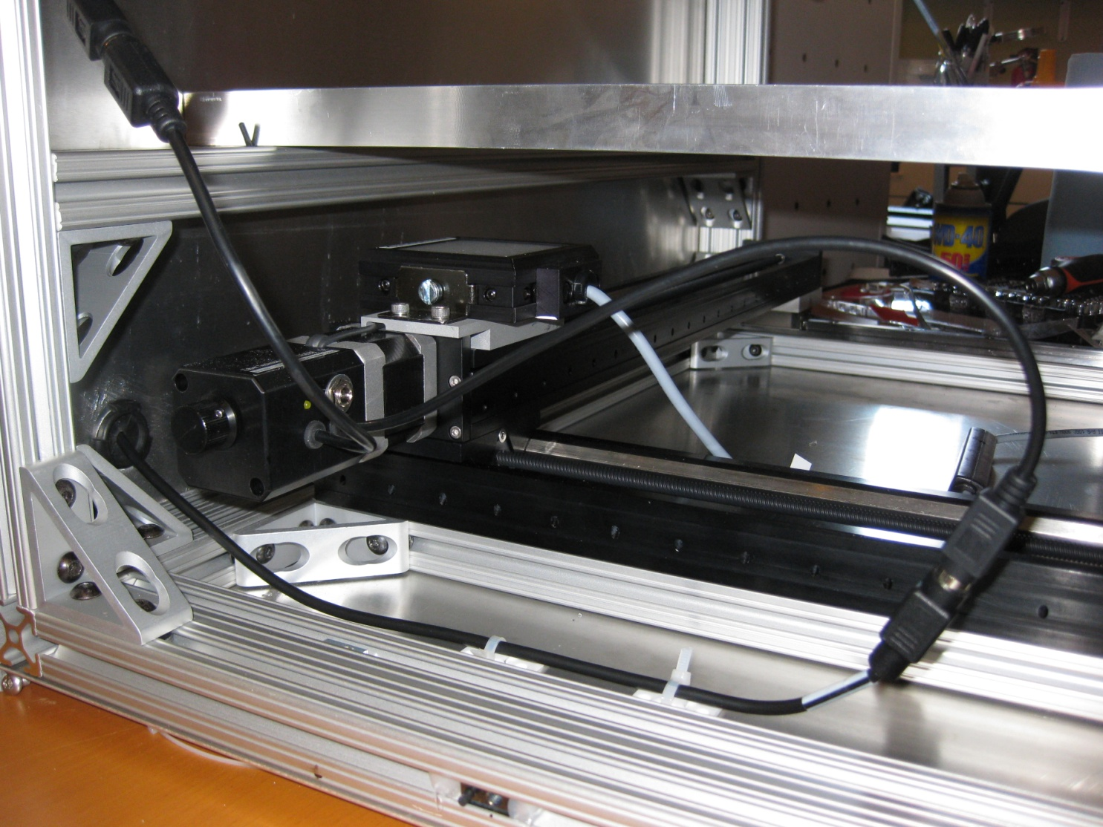

Panel LED backlight excess cabling was allowed to sit on the bottom of the assembly with no special handling provisions.

The Zaber drives were daisy-chained per Zaber. Only two Zaber drives were inside the housing (the upper and lower ‘Y’ drives). The lower ‘Y’ drive was powered from a line that came into the back wall (through a rubber grommet) as shown. The lower ‘Y’ drive was daisy-chained to the upper ‘Y’ drive.